L&T Hub: Designing & Delivering a Lesson Plan
Lesson Plan A: EAS Model Structure

Tutor: Subject/class: Duration of class: Number of students:
Introduction  How you will introduce the topic/class. | Explanation  How you will explain the material. | Activity  How you will engage students. | Summary/sharing  How you will summarise or draw on your students’ knowledge. | Conclusion/feedback  How you will conclude the class and gather feedback from your students.
E.g. talk to your students about the main points from the lecture | Activity 1: Name |  |  | Gather information on what has been learnt and if your students’ perceptions have been changed.
 | E.g. discuss with the class the varied types of marketing that is available to small business | Provide the class with a list of key concepts to be researched on small business marketing. Each group will be asked to research a single topic. Each explanation of a concept will need to be supported with an example. | Discuss the presentation of the concepts, linking important points.
 | Activity 2: Name

L&T Hub: Designing & Delivering a Lesson Plan
Lesson Plan B: General Planning Template
Tutor: Subject/class: Duration of class: Number of students:
Time | Activity | Purpose | Assessment & SLO Links | Resources
5 minutes

L&T Hub: Designing & Delivering a Lesson Plan
Lesson Plan C: Visual Planning Template
Subject: Lesson: Date:
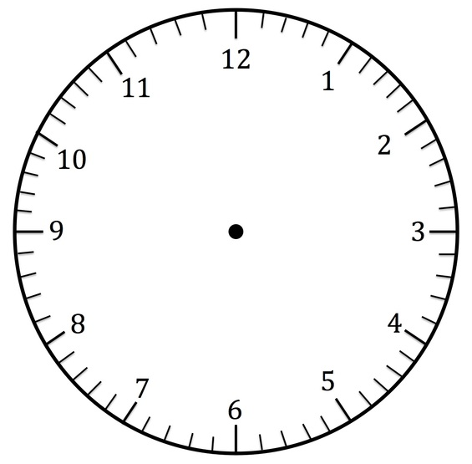
Details:

